Rmarkdown_1
Gayatri Bhandari
2026-02-18
## mpg cyl disp hp
## Min. :10.40 Min. :4.000 Min. : 71.1 Min. : 52.0
## 1st Qu.:15.43 1st Qu.:4.000 1st Qu.:120.8 1st Qu.: 96.5
## Median :19.20 Median :6.000 Median :196.3 Median :123.0
## Mean :20.09 Mean :6.188 Mean :230.7 Mean :146.7
## 3rd Qu.:22.80 3rd Qu.:8.000 3rd Qu.:326.0 3rd Qu.:180.0
## Max. :33.90 Max. :8.000 Max. :472.0 Max. :335.0
## drat wt qsec vs
## Min. :2.760 Min. :1.513 Min. :14.50 Min. :0.0000
## 1st Qu.:3.080 1st Qu.:2.581 1st Qu.:16.89 1st Qu.:0.0000
## Median :3.695 Median :3.325 Median :17.71 Median :0.0000
## Mean :3.597 Mean :3.217 Mean :17.85 Mean :0.4375
## 3rd Qu.:3.920 3rd Qu.:3.610 3rd Qu.:18.90 3rd Qu.:1.0000
## Max. :4.930 Max. :5.424 Max. :22.90 Max. :1.0000
## am gear carb
## Min. :0.0000 Min. :3.000 Min. :1.000
## 1st Qu.:0.0000 1st Qu.:3.000 1st Qu.:2.000
## Median :0.0000 Median :4.000 Median :2.000
## Mean :0.4062 Mean :3.688 Mean :2.812
## 3rd Qu.:1.0000 3rd Qu.:4.000 3rd Qu.:4.000
## Max. :1.0000 Max. :5.000 Max. :8.000

How to include figure
## Warning: package 'ggplot2' was built under R version 4.4.3
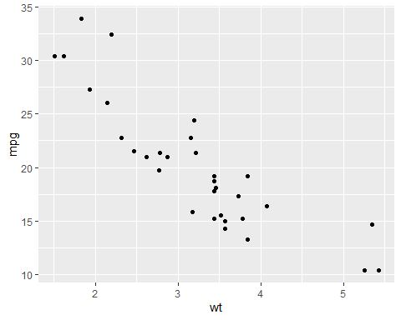

First level header
GB

Second level header
Gayatri Bhandari

Third level header
- one item
- second item

Links
link to my github

Image
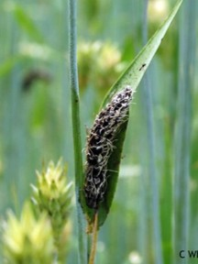
fungus

Formatted table
 | mpg | cyl | disp | hp | drat | wt | qsec | vs | am | gear | carb
Mazda RX4 | 21.0 | 6 | 160.0 | 110 | 3.90 | 2.620 | 16.46 | 0 | 1 | 4 | 4
Mazda RX4 Wag | 21.0 | 6 | 160.0 | 110 | 3.90 | 2.875 | 17.02 | 0 | 1 | 4 | 4
Datsun 710 | 22.8 | 4 | 108.0 | 93 | 3.85 | 2.320 | 18.61 | 1 | 1 | 4 | 1
Hornet 4 Drive | 21.4 | 6 | 258.0 | 110 | 3.08 | 3.215 | 19.44 | 1 | 0 | 3 | 1
Hornet Sportabout | 18.7 | 8 | 360.0 | 175 | 3.15 | 3.440 | 17.02 | 0 | 0 | 3 | 2
Valiant | 18.1 | 6 | 225.0 | 105 | 2.76 | 3.460 | 20.22 | 1 | 0 | 3 | 1
Duster 360 | 14.3 | 8 | 360.0 | 245 | 3.21 | 3.570 | 15.84 | 0 | 0 | 3 | 4
Merc 240D | 24.4 | 4 | 146.7 | 62 | 3.69 | 3.190 | 20.00 | 1 | 0 | 4 | 2
Merc 230 | 22.8 | 4 | 140.8 | 95 | 3.92 | 3.150 | 22.90 | 1 | 0 | 4 | 2
Merc 280 | 19.2 | 6 | 167.6 | 123 | 3.92 | 3.440 | 18.30 | 1 | 0 | 4 | 4
Merc 280C | 17.8 | 6 | 167.6 | 123 | 3.92 | 3.440 | 18.90 | 1 | 0 | 4 | 4
Merc 450SE | 16.4 | 8 | 275.8 | 180 | 3.07 | 4.070 | 17.40 | 0 | 0 | 3 | 3
Merc 450SL | 17.3 | 8 | 275.8 | 180 | 3.07 | 3.730 | 17.60 | 0 | 0 | 3 | 3
Merc 450SLC | 15.2 | 8 | 275.8 | 180 | 3.07 | 3.780 | 18.00 | 0 | 0 | 3 | 3
Cadillac Fleetwood | 10.4 | 8 | 472.0 | 205 | 2.93 | 5.250 | 17.98 | 0 | 0 | 3 | 4
Lincoln Continental | 10.4 | 8 | 460.0 | 215 | 3.00 | 5.424 | 17.82 | 0 | 0 | 3 | 4
Chrysler Imperial | 14.7 | 8 | 440.0 | 230 | 3.23 | 5.345 | 17.42 | 0 | 0 | 3 | 4
Fiat 128 | 32.4 | 4 | 78.7 | 66 | 4.08 | 2.200 | 19.47 | 1 | 1 | 4 | 1
Honda Civic | 30.4 | 4 | 75.7 | 52 | 4.93 | 1.615 | 18.52 | 1 | 1 | 4 | 2
Toyota Corolla | 33.9 | 4 | 71.1 | 65 | 4.22 | 1.835 | 19.90 | 1 | 1 | 4 | 1
Toyota Corona | 21.5 | 4 | 120.1 | 97 | 3.70 | 2.465 | 20.01 | 1 | 0 | 3 | 1
Dodge Challenger | 15.5 | 8 | 318.0 | 150 | 2.76 | 3.520 | 16.87 | 0 | 0 | 3 | 2
AMC Javelin | 15.2 | 8 | 304.0 | 150 | 3.15 | 3.435 | 17.30 | 0 | 0 | 3 | 2
Camaro Z28 | 13.3 | 8 | 350.0 | 245 | 3.73 | 3.840 | 15.41 | 0 | 0 | 3 | 4
Pontiac Firebird | 19.2 | 8 | 400.0 | 175 | 3.08 | 3.845 | 17.05 | 0 | 0 | 3 | 2
Fiat X1-9 | 27.3 | 4 | 79.0 | 66 | 4.08 | 1.935 | 18.90 | 1 | 1 | 4 | 1
Porsche 914-2 | 26.0 | 4 | 120.3 | 91 | 4.43 | 2.140 | 16.70 | 0 | 1 | 5 | 2
Lotus Europa | 30.4 | 4 | 95.1 | 113 | 3.77 | 1.513 | 16.90 | 1 | 1 | 5 | 2
Ford Pantera L | 15.8 | 8 | 351.0 | 264 | 4.22 | 3.170 | 14.50 | 0 | 1 | 5 | 4
Ferrari Dino | 19.7 | 6 | 145.0 | 175 | 3.62 | 2.770 | 15.50 | 0 | 1 | 5 | 6
Maserati Bora | 15.0 | 8 | 301.0 | 335 | 3.54 | 3.570 | 14.60 | 0 | 1 | 5 | 8
Volvo 142E | 21.4 | 4 | 121.0 | 109 | 4.11 | 2.780 | 18.60 | 1 | 1 | 4 | 2

